250 CT Portfolio Exercise 1
Academic year 2019/2020

Read me 1st

This activity is part of the coursework portfolio for this module. This activity needs to be signed off by a member of staff teaching in this module. You must do portfolio exercises in the order provided. Ensure each activity is completed prior to attempting the next one. Ideally students should work in groups of two.

1. Basic connectivity

As part of this activity students are required to connect the computers together and/or with networking devices.

1.1 Connect a PC to a console port of a router

For this exercise you need to establish a link between the serial port of a PC and a console port of a router in the equipment cabinet. To achieve this you will need to use the serial (RS232) to RJ45 adapter on the back of the PC, and deploy a roll-over (also known as console) cable to connect from the patch panel in the cabinet to the console port of the router. Cables in the labs are colour coded – blue for straight-through, red for crossover and black for console cables. Ensure the number of the computer match the number used in the wiring cabinet patch panel.

Now use “MobaXterm” - should be able to find a short-cut on the desktop - to communicate with the router. To achieve this you need to:
- open MobaXterm
- click 'Sessions' and then click 'New session'
- click 'Serial'
- select 'COM1 (Communications Port (COM1))' for ‘Serial port’
- select '9600' for ‘Speed (bps)’
- Advanced Serial settings should be as follows
Bits per-second: 9600
Data-bits: 8
Parity: no parity
Stop bits: 1
Flow control: no flow control
- then click OK

If the connection was successfully a command prompt or a login request should appear on the screen. Show this to your instructor (in order to get signed of) and then exit without saving changes.

1.2 Simple point to point network between two PCs

Set up a simple point to point network by direct connection using a crossover cable (red cable in this lab) to connect the Ethernet adaptors of the two PCs together. Configure the PCs using the following addresses, where X is the number of the PC:

IP address for PC 1: 192.10.2.X
IP address for PC 2: 192.10.2.X
Subnet mask: 255.255.255.0

(note: the number of the PC is written on a sticker on the top of the computer tower case –also if crossover cables are not long enough you can connect the computers together through the patch panel)

To complete this task you need to demonstrate to the instructor that:

- The PCs are configured properly by typing “ipconfig” in the command prompt (start → run → cmd)
- The PCs can communicate with each other by “pinging” PC1 from PC2 and vice versa using the “ping <ip address of other PC>” command in the command prompt.

1.3 Simple network using a hub/switch
Set up a simple network using a hub/switch via the Cisco Packet Tracer,
Please demonstrate to the instructor that your network works as you did in the previous exercise (use the same IP addresses as in 1.2), and further provide the evidences of your work as shown below:
- Please provide the screenshot of your system on the Cisco Packet Tracer.

- Please fill in the diagram provided.
Note: Please fill in the missing information in the following diagram – this will be marked and needs to be submitted alongside the reset of the portfolio exercises.

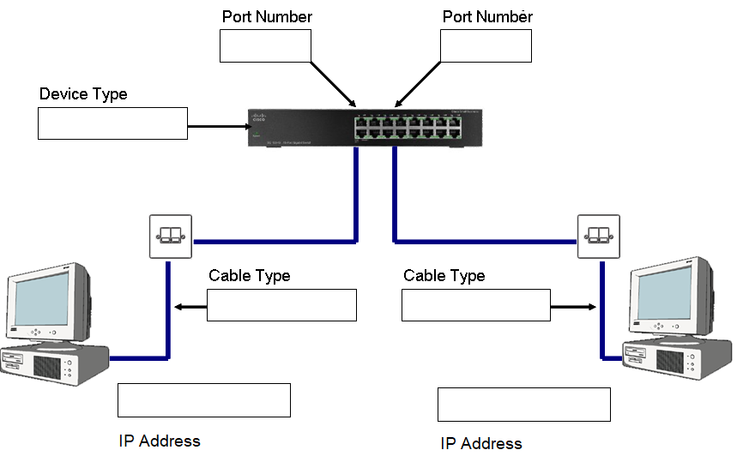

Wiring Diagram for Activity 3 – Please fill in the gaps
250 CT Portfolio Exercise 1
Submission Instructions

Group Members

Ideally these tasks should be completed in groups of two. Groups of three are allowed but not recommended. Please indicate the group members for this portfolio exercise.

Name: Student ID:

Name: Student ID:
…................................................................................................
Name: Student ID:

Instructor signatures

After completing each task, demonstrate to the instructor that the task was completed successfully in order to be signed off. Signatures indicate that the student/group successfully completed and demonstrated the activities at a satisfactory level, and as such, they contribute towards the marks allocated for these activities.

Portfolio Submission

You are required to fill in the portfolio exercise sheets. Those are to be submitted later (all portfolio exercises to be submitted together) as indicated by the module guide/schedule. The completion level and correctness of the submitted portfolio exercise sheets contributes towards you mark.

